File Integrity Verification Using Hashing

Project Description
This project demonstrates the process of verifying file integrity by using cryptographic hashing. Even if two files appear to contain the same data, their actual binary representation may differ. To accurately check for differences, cryptographic hash functions such as SHA-256 can be used. By generating and comparing hashes, analysts can validate whether two files are truly identical or not.
This project simulates a scenario where two files (file1.txt and file2.txt) appear identical when viewed but must be checked for integrity differences using hashing tools.

Tasks

Task 1: Generate Hashes for Files
List the files in the working directory
ls
Files found: file1.txt and file2.txt.
Display the contents of the files
cat file1.txt
cat file2.txt
Both files display identical content:
X5O!P%@AP[4\PZX54(P^)7CC)7}$EICAR-STANDARD-ANTIVIRUS-TEST-FILE!$H+H*
Observation: Contents appear the same.

Generate SHA-256 hashes

sha256sum file1.txt
sha256sum file2.txt
Output:
131f95c51cc819465fa1797f6ccacf9d494aaaff46fa3eac73ae63ffbdfd8267 file1.txt
2558ba9a4cad1e69804ce03aa2a029526179a91a5e38cb723320e83af9ca017b file2.txt
Observation: Hash values are different → files are not identical.
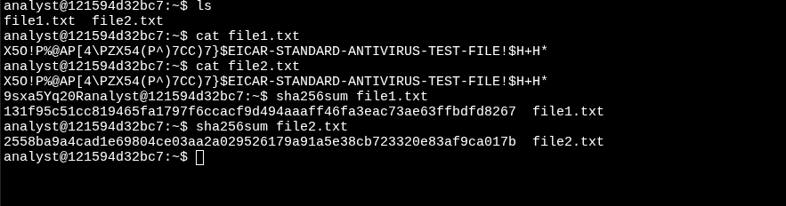

Task 2: Compare Hashes
Save hash values into separate files
sha256sum file1.txt >> file1hash
sha256sum file2.txt >> file2hash

Display and review hashes
cat file1hash
cat file2hash
Confirms that file1hash and file2hash store different SHA-256 values.
Compare hash files byte by byte
cmp file1hash file2hash
Output:
file1hash file2hash differ: char 1, line 1
Observation: Hash files differ from the very first character, confirming that the original files are different.
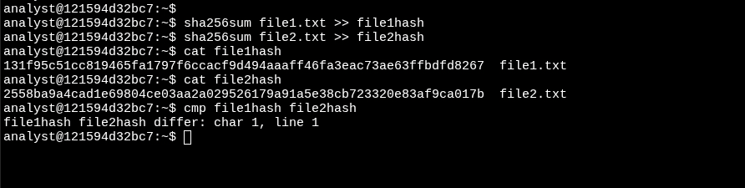

Summary
In this project, I practiced verifying file integrity using hashing techniques.
- Used cat to display file contents (appeared identical).
- Generated SHA-256 hashes with sha256sum.
- Observed that identical-looking files produced different hash values.
- Saved hashes into separate files and used cmp to confirm differences at the binary level.
Key Takeaway: Even when files appear the same visually, hashing ensures accurate integrity verification. This skill is essential in digital forensics, cybersecurity, and data validation tasks.

